Lab 9

Objectives:

The main objective of this lab is how to use Object Oriented programming in C# programs. The main focus is how to add a class in a program. To declare instance variables and to set their scope. How to define access methods and functions of class, how to implement security of instance variables by making them private and implementing properties to access them, how to overload a method or function and to use shared variables in a class is the main objective of this lab exercise.

Program 1:
Create a Point Class consisting of two members x and y. Override Tostring() method and inherit Circle class from the Point Class that should include one data member radius and calculate area and circumference of a circle.

public class Point
{
protected int xval, yval;
public Point()
{
}
public Point(int x, int y)
{
xval = x;
yval = y;
}
public void setxval(int x1)
{
xval = x1;

}
public void setyvalue(int y1)
{
yval = y1;

}
public override string ToString()
{

return xval+ "\t" + yval;

}
}
public class Circle : Point
{
private double radius;
public Circle()
{
}
public Circle(int x, int y,double r)
{ xval=x;
yval=y;
radius=r;
}
public void setradius(double r1)
{
radius=r1;
}
public virtual double Area()
{
return Math.PI* radius*radius;
}
public override string ToString()
{
return " The center of a circle is " + base.ToString() + " Radius is " + radius;
}
}

private void Form1_Load(object sender, EventArgs e)
{
string output;
Point P = new Point(10, 56);
output = P.ToString();

textBox1.Text = output + Environment.NewLine;
P.setxval (20);
P.setyvalue( 34);
textBox1.Text += P.ToString();
Circle C = new Circle(34,67,8);
textBox1.Text += Environment.NewLine + C.ToString();
}

Program 3
Write a BankAccount class which ill ask the user for the following details- account number, customer’s name & balance. Customer may deposit some money when opening a new account & so this is the opening balance. Then allow the customer to deposit & withdraw money. The user should enter the amount of money for each of these transactions and the current balance should always be displayed.

Steps
- Open a new project. Build the form using the following figure. Name the three text boxes txtAccountNumber, txtCustomerName and txtBalance. Name the other controls as you feel appropriate.

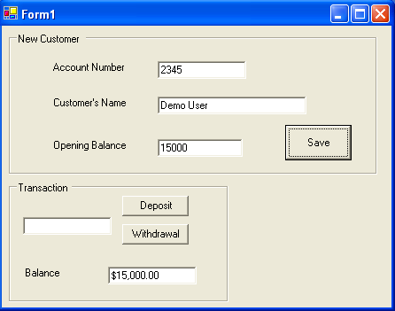

Program 4(Do it your self)

(A) Create a class, which should contain following instance variables, methods, properties and constructor
- Instance variables: Speed, Numberofdoors, Hpower, Gear, and Color
- Initialize a Constant variable: Enginenumber

- Provide Properties to manipulate every private variable
- Initialize three constructor with different number of parameter/argument
- Provide method Accelerate ( ), which increase the speed of the car by:
  - gradually (1 by 1)
  - value given by user
- Provide another method IsMoving ( ), which return true if the speed of the care is greater then Zero (0) and return false if the speed of the car is 0

(B) Create a Main program, which perform following task:
- Initialize three objects of class car. Each object initialized by different parameter, in such a way that all the constructor that you create in car class could be use
- Display values of all the instance variables of car class
- Assign new values to all the instance variables of car class
- Display new values of all the instance variables of car class
- Call Accelerate ( ) method without given any value as an argument
- Display value of instance variable Speed
- Call Accelerate ( ) method with some integer value as an argument
- Display value of instance variable Speed
- Assign value Zero (0) to the instance variable Speed of car class
- Call IsMoving ( ) method and check whether car is moving or not
- Call Accelerate ( ) method
Call IsMoving ( ) method and check whether car is moving or not. If moving then what is the speed.

Program 5

Create a Calculator class that offers four methods. Add, subtract, multiply and Divide. Consisting of two private members of type double to take input from the user. Create object of a class and start using the calculator class.

